**SCHOOL WASH ASSESSMENT IN KAPCHORWA DISTRICT**

**COVID-19 RESPONSE FOR SAFE LEARNING IN SCHOOLs**

*Schools, as we all know, not only teach children but also provide nutrition, health, and hygiene services, along with mental health and psychosocial support, while reducing incidents of violence against children, gender-based violence, and unintended pregnancy.*

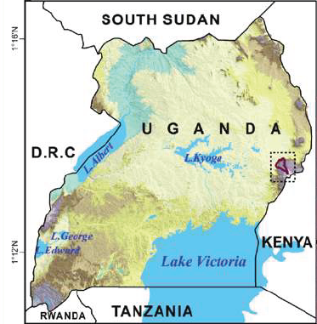

MWOK PARTNERSHIP FOR COMMUNITY RESILIENCE

**BASELINE REPORT**

**APRIL 2021**

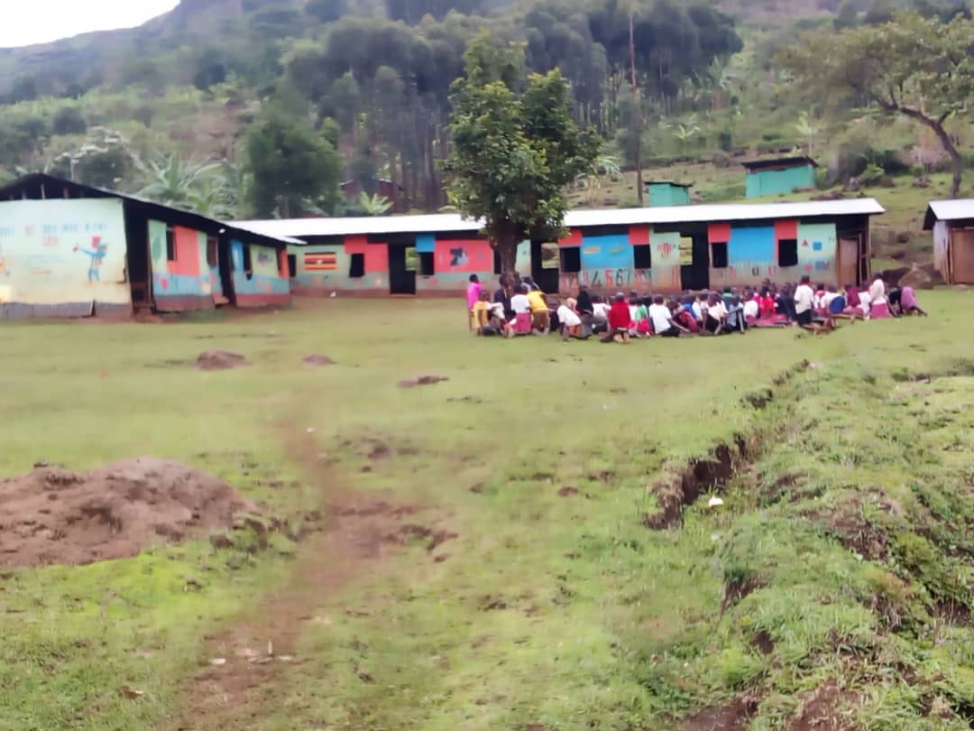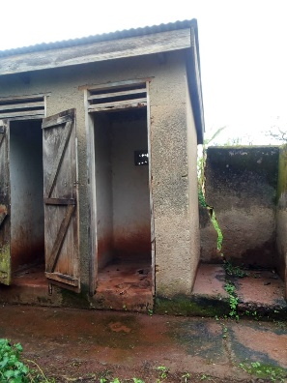

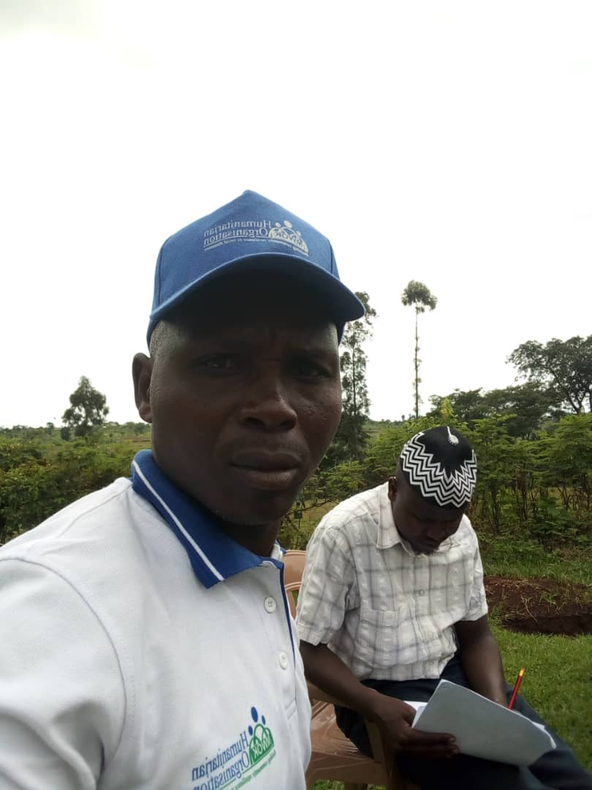



**CONTENTS**

Executive Summary 3

1. Background/Context 5
2. Rationale 7
3. Objectives 8
4. Methodology 9
5. Key findings 10
6. Recommendations for Joint Actions 17

Appendix 18

Annex 1: WASH Baseline assessment tool

**EXECUTIVE SUMMARY**

**Background/Rationale**: COVID-19 has caused the death of millions of people worldwide. Countries around the world took broad public health and social measures (PHSM), including closures of schools, to prevent the spread of the SARS-CoV-2 virus, which causes COVID-19. With close to 15 million children in Uganda affected by COVID-19 lockdown, and school closure, government is currently balancing the public health requirements of the nation with the urgent educational and developmental needs of future generations. Because of this, the safe reopening of schools should be given a high priority to prevent children from falling behind, to help them recover from education gaps and to keep children learning in a safe environment.

**Objective:** The main purpose of baseline is to ascertain underlying factors of public health importance in COVID-19 prevention and mitigation to ensure safe learning school environments in the district.

**Method/Approach**: This was a cross-sectional survey that employed largely quantitative approaches including observations to gather relevant data required for the baseline from randomly selected schools in Kapchorwa district, Sebei region. Total of 30 schools (i.e., 20 primary and 10 secondary schools) participated. The primary respondents were the school administrators (i.e., School Management Committee) under the leadership of the Head Teachers. SOP for COVID-19 of wearing facemasks, handwashing and sanitization was strictly adhered to by all volunteers during the rapid assessment.

**Key findings:**

* 93.3% of the schools are located in rural areas of Kapchorwa
* 96.7% of the schools are protected with fetch (temporary or permanent) and ensure safety of the school environment for leaners.
* 70% of the schools do not have vegetable gardens
* 16.7% most of the schools do not have visible garbage and refuse in the school environments
* 93.3% of the schools have adequate water supply, tap water as main source water supply for schools.
* 86.7% of the schools treat drinking water using chlorine to treat water (67%)
* 40% of the schools used traditional pit latrines for excreta disposals. Most of the schools (96.7%) in the district have excreta facilities that are for teachers separate from learners.
* 80% of the schools have hand washing facilities, 33.3% had no water and no soap
* 13.3% of the schools had no hygiene promotion activities in spite of 86.7% supporting lessons and curricula on hygiene
* 43.3% of the respondents said that the health development agent does not come to teach students about hygiene.
* 60% of the respondents said that parents did not involve in the school wash programs

**Recommendations for actions:**

* Step-up risk awareness campaign and risk communication on COVID-19 and prevention measures through local media and use of IEC materials in schools
* Provision of handwashing facilities and soap to vulnerable schools in urban and rural Kapchorwa
* Critical structures for excreta disposal facilities -most traditional pit latrines assessed are in poor status.
* Re-vitalization of Hygiene promotion in all schools using school health clubs
* Enforce and strengthen health inspections in all learning institutions in the district
* Strengthen coordination of hygiene practice at schools and homes through involvement of the parents and community leaders
* Effective collaboration and partnership for implementation of DRR measures to prevent/mitigate disasters especially disease outbreaks/epidemics/pandemic, etc
* Advocacy for funding to support adolescent health services in school to prevent teenage /unwanted pregnancies and thus, reduce drop out rate and improve school completion rate in Kapchorwa district

**1. BACKROUND/CONTEXT**

**1.1. Overview of Kapchorwa District**

### **Population**

Kapchorwa District had a total population of 104,580 people (Census (2014). Majority of the people in Kapchorwa District reside in rural areas (92,235 (88.2%) compared to (12,345 (11.8%) who reside in urban centers. The gender distribution of Kapchorwa is males: 51,169 (48.9%) and females: 53,411 (51.1%). About 99.3% (103,808) of the population form the household population and only 0.7% (772) is non-household. Kapchorwa Town council had the highest population of 12,345 people while Gamogo sub-county had the least population of 3,308 people.

### **Economic activities**

Agriculture is the main economic activity in the district. The district is very productive in agricultural products and is a food basket to most of the Districts in Uganda. Most people in the district produce crops for commercial purposes and little is left for home consumption. Cash crops like coffee, Burley and wheat are purely for cash. The main crops grown are coffee, maize, beans, barley, wheat, matooke, Irish Potatoes, millet, Sun flower, cow peas and passion fruit. Other economic activities include agro-processing of mainly maize and coffee. Livestock farming – cows, sheep, goats, donkeys and pigs. Also, poultry, bee keeping and eco – tourism among other economic activities are also practiced in the district. Vegetable growing has greatly increased with markets as far as Southern Sudan. They include Cabbages, Onions, Carrots, Tomatoes and Sukuma, Other petty trade and transport business is common.

**1.2. Impact of COVID-19 on education**

Since the declaration of COVID-19 as a pandemic by the WHO in December 2019, world wide spread havoc and disruptions in the previously known normal way of life have been witnessed all over the Continent. Covid 19, has caused the death of millions of people worldwide. Countries around the world have taken broad public health and social measures (PHSM), including closures of schools, to prevent the spread of the SARS-CoV-2 virus, which causes COVID-19. The closures of schools as measures to control the spread of the pandemic have had serious negative impacts on communities and pupils. It is now acknowledged that it is in the best interest of all stakeholders including the pupils/students, parents, teachers, community, the government and the economy, to do everything possible to have the schools closure times minimized and to build the ability of schools to withstand, absorb and adapt to these kinds of shocks and stresses in order to maintain continued learning despite the disruptions. The principles underlying the considerations for school-related public health measures to prevent and minimize SARS-CoV-2 transmission in school settings include: Ensuring continuity of safe, adequate and appropriate educational and social learning and development of children; Minimizing the risk of SARS-CoV-2 transmission within school and school-associated settings among children, teachers and other school staff; Guarding against the potential for schools to act as amplifiers for transmission of SARS-COV-2 within communities; Ensuring school-related PHSM are integrated into and support the wider measures implemented at the community level.

**1.2.1. Schools as possible hotspots and incubators for community transmission**

The school’s potential to act as incubators and amplifiers of transmission cannot be over emphasized. The risk of community transmission from persons infected with COVID 19, 60-80% of whom have no symptoms is very high. The management of cases at school, complacency, keeping quiet about cases etc have been observed to be real challenges in school covid 19 prevention and management. Day Schooling and the resultant interactions among learners from multiple households which can amplify transmission in a silent outbreak, to other people including vulnerable individuals in their homes, learners acquiring or transmitting disease via transportation to school and in school which can easily involve workplaces of the parents of affected children, among others.

Schools are known institutions of crowding, many with limited social and sanitation facilities that is likely to compromise control measures. Complexity in responding to a confirmed case in an Education Institution or a home of a child that is likely to cause public outrage, and reputational risk for health and education services managers. Stigma and traumatic stress in Education Institution setting for children compound covid 19 management challenges

## **1.2.2. Government COVID-19 response on education**

On 15th October 2020, H.E the President directed the partial opening of learning institutions for candidate classes as one of the measures to ease the COVID 19 lockdown. Pursuant to this, Ministry of Education and Sports (MoES) developed “Guidelines for the phased reopening of education institutions” that requires Ministry of Health (MoH) to provide complementary Standard Operating Procedures (SOPs) outlining the mechanisms for maintaining sustained risk communication, infection prevention, surveillance in education institutions, psychosocial support, and linking the education institution COVID-19 control activities to the District Task Force. MoH and MoES was to provide technical support to districts in the roll out of the activities, as well as advocate for and support efforts to raise resources to implement the proposed actions. The SOPs were intended for use by policy-makers, educators, health providers, local authorities, communities and parents who make decisions on or are involved in running schools as safely as possible during the COVID-19 pandemic while ensuring the continuity of education for the children,

## **1.2.3. Ministry of education Covid-19 school operations guidelines**

The MoES developed guidelines to support Education Institution administrators on step-by-step implementation of COVID 19 public health prevention and control measures in Education Institutions. To instruct on routine surveillance of learners and staff for prompt detection of and action on COVID 19 Outbreak in Education Institutions and, to guide investigation of alerts on SARS-CoV-2 infection in schools and other educational institutions. To create awareness among stakeholders on guarding against potential for schools to act as amplifiers for transmission of SARS-COV-2 within communities and mitigation measures. To ensure the Primary Health Care Facilities and District Task Forces have oversight on COVID 19 Control measures in Education Institutions

**2. RATIONALE**

Uganda announced its first COVID-19 patient on 20th March,2020 and since then the number is increasing day by day ( currently 28,168 cases with 225 deaths and 10,005 recoveries reported as at 16th December 2020) and the role of frontliners including facility health workers and Village Health Teams (VHTs) also referred to as Community Health Workers, parents and children and community leaders at large is paramount in fighting the pandemic and maintaining existing essential health service delivery ensuring safety through adherence to MOH’s Standard Operating Procedures (SOPs). With close to 15 million children in Uganda affected by those closures, government is currently balancing the public health requirements of the nation with the urgent educational and developmental needs of future generations. Uganda has recognised education as a powerful tool for social, economic development and transformation. Education had been considered critical for the achievement of national unity, democracy and social justice for all citizens. Likewise, Uganda’s vision 2040 recognises education as a key endogenous driver of economic growth, providing human capital development needed to strengthen and to accelerate the country’s transformation and harness the demographic dividend (Vision, 2040).

Schools, as we all know, not only teach children but also provide nutrition, health, and hygiene services, along with mental health and psychosocial support, while reducing incidents of violence against children, gender-based violence, and unintended pregnancy. With each passing day that schools stay closed, the most vulnerable children will be the hardest hit. We know from previous crises that the longer such children are out of school, the less likely they are to return. Given Uganda's demography---with 54 per cent of the population under the age of 18 ---any disruptions to the education of our children will not only threaten the dreams and opportunities of those children, but the sustainable development of the nation, as well. Because of this, the safe reopening of schools should be given a high priority to prevent children from falling behind, to help them recover from education gaps and to keep children learning in a safe environment. Therefore, MWOK will work with Kapchorwa district local government through Education and Health departments to support planning to prepare for schools to reopen safely. While immediate priorities are on maintaining learning, it is important that schools are ready for children to return as soon as it is safe. It is critical that preparations start early to develop guidance and materials to support the safe preparedness plan in the district focusing on preventive activities as well as adaptation in COVID situations when schools reopen early 2021

**3. OBJECTIVES**

**3.1. Main objective:**

To ascertain underlying factors of public health importance in COVID-19 prevention and mitigation to ensure safe learning school environments in rural and urban in Kapchorwa district

**3.2. Specific Objectives:**

1. To assess the level of readiness of schools in terms of WASH facilities for implementation of COVID-19 measures for safe school re-opening and learning;
2. To assess school environments and current practices for implementation of minimum DRR measures for safety of pupils and teachers while in school environments; and
3. To develop/adapt MOH’s SOP for schools and ensure strengthening of local capacity of school administrators and staff and PTA to accelerate COVID-19 prevention and control steps in vulnerable schools in Kapchorwa

**4. METHODOLOGY**

**4.1. Study site/population:** This was conducted in selected schools in Kapchorwa District, Sebei region and it targeted primary and secondary schools in both urban, peri-urban and rural areas of the district. The primary respondents were the school administrators (i.e., School Management Committee) under the leadership of the Head Teachers

**4.2. Study design:** This was a cross-sectional survey that employed a quantitative approach including observations to gather relevant data required for the baseline from randomly selected schools in Kapchorwa district.

**4.3. Sampling technique:** Systematic random sampling technique was employed in selection of the schools for this baseline using the existing list of all primary and secondary schools in the district. The list of updated schools was obtained from the District Education Office (DEO) of Kapchorwa District Local Government. Total of 30 schools (i.e. 20 primary and 10 secondary schools) were randomly selected form the list of primary and secondary schools respectively.

**4.4. Data Collection:** A standardised tool was used to collect both quantitative and qualitative data from all the 30 selected schools on Readiness/Preparedness/DRR measures and WASH facilities (Refer to Annex 1 and 2 for details of checklist used). Tools were shared and cleared by the relevant office of Health and Education Department (DHO and DEO) of Kapchorwa district. A one-day orientation training was conducted for volunteers at MWOK Regional Office in Kapchorwa to familiarise them with the tools and data quality control.

**4.5. Data Analysis:** Data entry and analysis was performed using SPSS based on the variables. Both descriptive and Cross-tabulation frequencies were generated using SPSS to provide the information required for each specific objectives of the baseline.

**4.5. Ethical Consideration:** Clearance to conduct baseline was obtained from the office DHO and DEO respectively after going through the proposed approach. During field work, SOP for COVID-19 of wearing facemasks, handwashing and sanitization was strictly adhered to by all volunteers. Confidentiality of the school data was ensured during data management and reporting.

**5. KEY FINDINGS**

**5.1. Characteristics of the Schools**

Total of (N=30 schools, comprising 20 primary and 10 secondary schools) both government and private schools fully participated in this baseline assessment across the district. Respondents were Head Teachers/or Deputies, who were able to provide responses to the questions asked in the quantitative checklist.

**5.1.3. Location of schools in Kapchorwa district**

|  | Location | Frequency (n) | Percentage |
| --- | --- | --- | --- |
|  | Urban | 2 | 6.7% |
| Rural | 28 | 93.3% |
| Total | 30 | 100% |

Source: primary data (2021)

The study revealed that 93.3% of the schools are located in rural areas of Kapchorwa, 6.7% of the schools are located in the Urban center. This implies that most of the schools in Kapchorwa are located in the rural areas.

**5.2. ENVIRONMENTAL HEALTH AND WASH INDICATORS**

**5.2.1. Environmental health**

|  |  |  |
| --- | --- | --- |
| **Variables** | **(Frequency, n)** | **Percent (%)** |
| Availability of School fence | 29 | (96.7%) |
| Garbage visible (littering) in school compound | 5 | (16.7%) |
| Compound Beautified with flowers, shrubs | 28 | (93.3%) |
| School gardening (Student Vegetable gardens present) | 9 | (30%) |

Source: primary data (2021)

The findings reveal that 96.7% of the respondents said that the schools are protected to ensure safety of the schools by the school administration. Response on whether a student vegetable garden is available in the school, 70% of the respondents said no and 30% of the respondents said it was available. This implies that most of the schools in Kapchorwa district (70% majority) do not have a vegetable garden. In addition, 93.3% of the schools have flowers/shrubs in their compound. Response on whether garbage and refuse is visible in the school compound, 83.3% of the respondents said that it was not visible. The findings imply that most of the schools do not have visible garbage and refuse in the school environments

**5.2.2. Maintenance of classrooms**

|  | Response | Frequency | Percentage |
| --- | --- | --- | --- |
|  | very good | 1 | 3.3% |
| good | 26 | 86.7% |
| poor | 3 | 10% |
| Total | 30 | 100% |

Source: primary data (2021)

Response on whether school classrooms are maintained in among schools in Kapchorwa district, 86.7% of the respondents that they were in a good state, 10% of the respondents said that they were poor, 3.3% of the respondents said that they were very good. The findings from the study imply that most of the schools form the baseline survey have good maintained classrooms for learners

**5.3. WASH FACILITIES IN SCHOOLS**

**5.3.1. Water supply**

|  |  |  |
| --- | --- | --- |
| **Variables** | **Frequency, n** | **(Percent %)** |
| Schools with a water source | 28 | (93.3%) |
| Type of water source |  |  |
| Pump | 4 | (13.3) |
| Ponds | 1 | (3.3%) |
| Others | 22 | (73.3%) |
| Schools with drinking water in class rooms | 3 | (10%) |
| Storage of water in classroom |  |  |
| Jerry can | 3 | (10%) |
| other | 5 | (16%) |
| Schools with adequate water for the school population | 25 | (83.3%) |
| Schools that treat drinking water | 26 | (86.7%) |
| By Boiling | 5 | (16.7%) |
| By Filtration | 1 | (3.3%) |
| By Chlorination | 19 | (63.3%) |

Source: primary data (2021)

93.3% of the respondents said that schools have a water supply indicating that most of the schools in Kapchorwa district have a water supply. The main source of water supply being water pumps (13.3%), pond/river (3.3%) and other sources (73.3%). Response on whether water is adequate for the school population, 83.3% of the respondents said that the water was adequate for the school’s population. Majority (86.7%) of the respondents said that schools treat drinking water. Main treatment is by use of chlorine tabs

**Methods of treating drinking water**

| Response |  | Frequency | Percentage |
| --- | --- | --- | --- |
|  | boiling | 5 | 16.7% |
| filter | 1 | 3.3% |
| chlorine | 19 | 63.3% |
| other | 2 | 6.7% |
| Total | 27 | 90% |
| Missing | System | 3 | 10% |
| Total | | 30 | 100% |

Source: primary data (2021)

Response on how water is stored among schools in Kapchorwa district, 10% of the respondents said that they stored water in Jerrican, 6.7% of the respondents said that they use other means in storing water. 83.3% of the respondents missed out answering this indicator, the findings from the baseline survey indicate that most of the schools in

**5.3.2. Excreta disposal at schools**

|  |  |  |
| --- | --- | --- |
|  | Frequency, n | (Percent, %) |
| Presence of an excreta disposal facility | 30 | (100%) |
| Schools with properly sited facilities | 30 | (100%) |
| Type of facility |  |  |
| Traditional Pit Latrine | 12 | (40%) |
| Improved Traditional Pit Latrine | - | - |
| VIP Latrine | - | - |
| Schools with separate facilities for boys and girls | 30 | (100%) |
| Schools with separate facilities for teachers | 29 | (96.7%) |

Response on the type of excreta system in the different schools in Kapchorwa district, 40% of the respondents said that they used traditional pit latrines, the findings indicate that most of the schools use traditional pit latrine as their excreta disposal facility

**5.3.3. Hand Washing facilities in Schools**

|  |  |  |
| --- | --- | --- |
| **Variables** | **Frequency, n** | **(Percent, %)** |
| Schools that had hand washing facilities in the school | 24 | (80%) |
| Kind of hand washing facilities that schools had |  |  |
| Sink and faucet | - | - |
| Bucket | - | - |
| Basin | 1 | (3.3%) |
| Tippy tap | - | - |
| Other | 23 | (76.7%) |
| Schools that had the facility near the latrines | 15 | (50%) |
| Schools that had water in the containers | 20 | (66.7%) |
| Schools that had soap, ash, or other cleaning material near the wash stand | 20 | (66.7%) |
| Is there any reminder for hand washing near latrine | 29 | (96.7) |

The findings from the baseline survey indicate that there are hand washing facilities in 80% of schools in Kapchorwa district. 50% of the washing facility was near the latrine and water container. By the time of survey, 33.3% of the said that they did not have water in their containers. Only 66.7% of the schools use either soap or ash or other washing detergents near the wash stand while 33.3% of the schools had no soap, ash and other detergents near their wash stands.

**5.3.4. School WASH activities**

|  |  |  |
| --- | --- | --- |
| **Variables** | **Frequency, n** | **(Percent, %)** |
| Schools that had any hygiene promotion activities? | 29 | (86.7%) |
| Kind of hygiene promotion activities present in schools | - | - |
| Schools with supporting lesson plans/curricula? | 26 | (8.7%) |
| Schools with WASH supporting teaching materials? | 22 | (73.3%) |
| Schools that receive a health or development agent to teach students about hygiene | 17 | (6.7%) |
| Schools that had posters, other IEC materials with hygiene messages on walls | 28 | (93.3%) |
| School club with hygiene activities? | 17 | %56.7) |
| Schools with School to community hygiene promotion activities. | 7 | (23.3%) |
| Schools where Parent were involved in school WASH | 12 | (40%) |

Source: primary data (2021)

Response on whether the school has any hygiene promotion activities, 86.7% of the respondents said that the school had hygiene promotion activities. 86.7% of the respondents said that there are supporting lessons and curricula on hygiene in their school, 10% of the respondents said that there were no supporting lesson plans in their curricula. The findings from the baseline survey indicate that most of the schools have supporting lesson plans on hygiene in Kapchorwa district

73.3% of the schools have support teaching materials on hygiene in Kapchorwa district. Response on whether a health development agent comes teach students about hygiene, 56.7% of the respondents said that a health development agent comes to teach students about hygiene. 93.3% of the schools have posters and IEC materials on hygiene display on the wall.

Response on whether the school has a club with hygiene activities, 56.7% of the respondents said the school had a club with hygiene activities, 43.3% of the respondents said had no club in their school with hygiene activities, the findings from the baseline survey imply that most schools in Kapchorwa district have school club with hygiene activities

**6. RECOMMENDATIONS FOR JOINT ACTIONS:**

**School Based:**

* Step-up risk awareness campaign and risk communication on COVID-19 and prevention measures through local media and use of IEC materials in schools
* Provision of handwashing facilities and soap to vulnerable schools in urban and rural Kapchorwa
* Critical structures for excreta disposal facilities -most traditional pit latrines assessed are in poor status.
* Re-vitalization of Hygiene promotion in all schools using school health clubs

**District Education in collaboration with DHO/partners:**

* Enforce and strengthen health inspections in all learning institutions in the district
* Strengthen coordination of hygiene practice at schools and homes through involvement of the parents and community leaders
* Effective collaboration and partnership for implementation of DRR measures to prevent/mitigate disasters especially disease outbreaks/epidemics/pandemic, etc
* Advocacy for funding to support adolescent health services in school to prevent teenage /unwanted pregnancies and thus, reduce dropout rate and improve school completion rate in Kapchorwa district

**Annex 1: School WASH Survey Form**

**Interviewer ID: _________________________________**

**Date of Interview: _______________________________**

**General Information**

Name of District: _______________________________________________________

Name of School: ______________________________________________________

Name of School Director: _______________________________________________

Name of Deputy School Director: _________________________________________

Telephone Number: ____________________________________________________

Year Established: __________

Distance from Town ________ km

School Address –

Physical Address:

Postal Address:

**The School**

1. **Site**

|  |  |  |
| --- | --- | --- |
| 1.1 | School location: | **Urban**  **Rural** |
| 1.2 | Well drained (no stagnant water potential, flood potential, etc.)? | **Yes**  **No** |

1. **Compound**

|  |  |  |
| --- | --- | --- |
| 2.1 | Approximate size of compound (in square meters) | **_______M2** |
| 2.2a | Accident sources in compound (impounded pond, holes, open wells, open pit latrines, broken glass, waste metal, ditches, etc.) | **Yes**  **No** |
| 2.2b | *If Yes, describe:* |  |
| 2.3 | Is the school compound fenced? | **Yes**  **No** |
| 2.4 | Is garbage or refuse visible? | **Yes**  **No** |
| 2.5 | Is the compound beautified with flowers, shrubs, etc.? | **Yes**  **No** |
| 2.6 | Is there a student vegetable garden available? | **Yes**  **No** |

1. **Students and Teacher Population**

|  |  |  |  |
| --- | --- | --- | --- |
|  | **Total** | **No. of Males** | **No. of Females** |
| **Students** |  |  |  |
| **Teachers** |  |  |  |
| **Cleaners/Guards** |  |  |  |

1. **Classrooms**

|  |  |  |
| --- | --- | --- |
| 4.1 | Total number of classrooms: |  |
| 4.2 | Average number of pupils per classroom |  |
| 4.3a | What is the maintenance level of the classrooms (school buildings)? | **Very Good**  **Good**  **Poor** |
| 4.3b | *Please Explain:* |  |

**WASH Information**

1. **Safe and Adequate Water Supply**

|  |  |  |  |  |
| --- | --- | --- | --- | --- |
| 5.1a | Is there any type of water supply for the school? | | | **Yes**  **No** |
|  | If Yes, what is the source?  - Pump  - Pond  - River  - Well Other: ___________________________ | | |  |
| 5.2a | Do classrooms have drinking water? | | | **Yes**  **No** |
| 5.2b | If Yes, how is it stored?  - Jerry can  - Jar  - Bucket  - Other: ___________________________    *If no, where do students and teachers get water to drink?* | | |  |
| 5.3 | Is the water adequate for the school population? | | | **Yes**  **No** |
| 5.4 | Is the water safe (is it from a safe source such as a pump or covered well or treated)? | | | **Yes**  **No** |
| 5.5a | Does the school treat drinking water? | | | **Yes**  **No** |
| 5.5b | *If Yes, how is it treated?*  - Boiling  - Filter  - Chlorine  - SODIS  - Other: ____________________________ | | |  |
| 5.6 | How is drinking water distributed? | **- From storage tank through multiple faucets**    **- From storage through one outlet**    **- From storage by dipping containers** | | |
| 5.7 | If multiple faucets are available, what is the proportion of faucets to students? | | **___faucets: ___students** | |
| 5.8 | Are faucets in working condition? | | | **Yes**  **No** |
| 5.9 | Does the school maintain its faucets? | | | **Yes**  **No** |

1. **Excreta Disposal Facilities**

|  |  |  |
| --- | --- | --- |
| 6.1a | Is there an excreta disposal facility in the school? | **Yes**  **No** |
| 6.1b | If Yes, is it properly sited (safe distance from class rooms, water source, and offices)? | **Yes**  **No** |
| 6.1c | *If Yes: Type of system (circle one):*   * Traditional pit latrine (dirt floor supported by logs of wood, wood walls with mud plastered, corrugated iron roof or thatch) * Improved traditional pit latrine (washable cement floor, supported by logs or reinforced, wood and mud walls, corrugated iron or thatch roof) * VIP latrine (cement floor supported by reinforced iron bar or wood, wood and mud plastered or brick or block wall, corrugated iron roof or thatch roof cover, ventilated through installed vent pipes)   *If No, where do students and teachers go to urinate/defecate?* | |
| 6.2 | Are there separate facilities for boys and girls? | **Yes**  **No** |
| 6.3a | Are there separate latrines available for teachers? | **Yes**  **No** |
| 6.3b | If Yes, are they separate for male and female teachers? | **Yes**  **No** |
| 6.4 | Do facilities have doors or curtains for privacy? | **Good**  **Medium**  **Poor** |
| 6.5 | Can the facilities be locked for safety and privacy? | **Yes**  **No** |
| 6.6 | Is there wiping material available in the facilities? | **Yes**  **No** |
| 6.7 | Number of squat holes available for boys: |  |
| 6.8 | Number of squat holes available for girls: |  |

.

**Facility Cleanliness**

|  |  |  |
| --- | --- | --- |
|  | All feces deposited inside the pit? | **Yes**  **No** |
|  | Fecal material around pit on floor? | **High**  **Medium**  **Low/None** |
|  | Anal cleaning material on floor? | **Yes**  **No** |
|  | Latrine smells bad? | **Yes**  **No** |
|  | Latrine cleaning program? | **Yes**  **No** |

1. **Hand Washing Facilities**

|  |  |  |
| --- | --- | --- |
| 7.1a | Are there any hand washing facilities in the school? | **Yes**  **No** |
| 7.1b | If Yes, what kind of facility:  - Sink and faucet  - Bucket  - Basin  - Tippy tap  - Other: ______________________________ |  |
| 7.2 | Is the facility near the latrines? | **Yes**  **No** |
| 7.3 | Is there water in the containers? | **Yes**  **No** |
| 7.4 | Is there soap, ash, or other near the wash stand? | **Yes**  **No** |
| 7.5 | Is there any reminder for hand washing near latrine? | **Yes**  **No** |

1. **School WASH Activities**

|  |  |  |
| --- | --- | --- |
| 8.1a | Does the school have any hygiene promotion activities? | **Yes**  **No** |
| 8.1b | If yes, what kind? |  |
| 8.2 | Classroom lessons on hygiene? | **Yes**  **No** |
| 8.2a | Are there supporting lesson plans/curricula? |  |
| 8.2b | Are there supporting teaching materials? |  |
| 8. 3 | Does a health or development agent come to teach students about hygiene? | **Yes**  **No** |
| 8.4 | Posters, other IEC materials with hygiene messages on walls? | **Yes**  **No** |
| 8.5 | School club with hygiene activities? | **Yes**  **No** |
| 8.6 | School to community hygiene promotion activities? | **Yes**  **No** |
| 8.7 | Parent involvement in school WASH? | **Yes**  **No** |